1. **INTRODUCTION**

* 1. **Overview**

This report delves into the fascinating realm of business expenses and provides a visual exploration of the various expenditures incurred by different businesses. It showcases the distribution of expenses, identifies key cost drivers, and highlights areas of potential optimization or concern. The visual representations allow for intuitive analysis, facilitating a deeper understanding of expenditure patterns and their implications for business performance. Decision-makers, financial analysts, and stakeholders can gain valuable insights into the financial health of businesses, identify areas of inefficiency or opportunity, and make informed decisions to optimize resources and drive growth. To Extract the Insights from the data and put the data in the form of visualizations, Dashboards and Story we employed Tableau tool**.**

* 1. **Purpose**

To accomplish this, we have to complete all the activities listed below,

● Define Problem / Problem Understanding o Specify the business problem o Business requirements o Literature Survey o Social or Business Impact.

● Data Collection & Extraction o Collect the dataset o Connect Dataset with Tableau

● Data Preparation o Prepare the Data for Visualization

● Dashboard Responsive and Design of Dashboard

● Story o No of Scenes of Story

● Web Integration o Dashboard and Story embed with UI With Flask

**PROBLEM DEFINITION & DESIGN THINKING**

**2.1 Empathy Map**

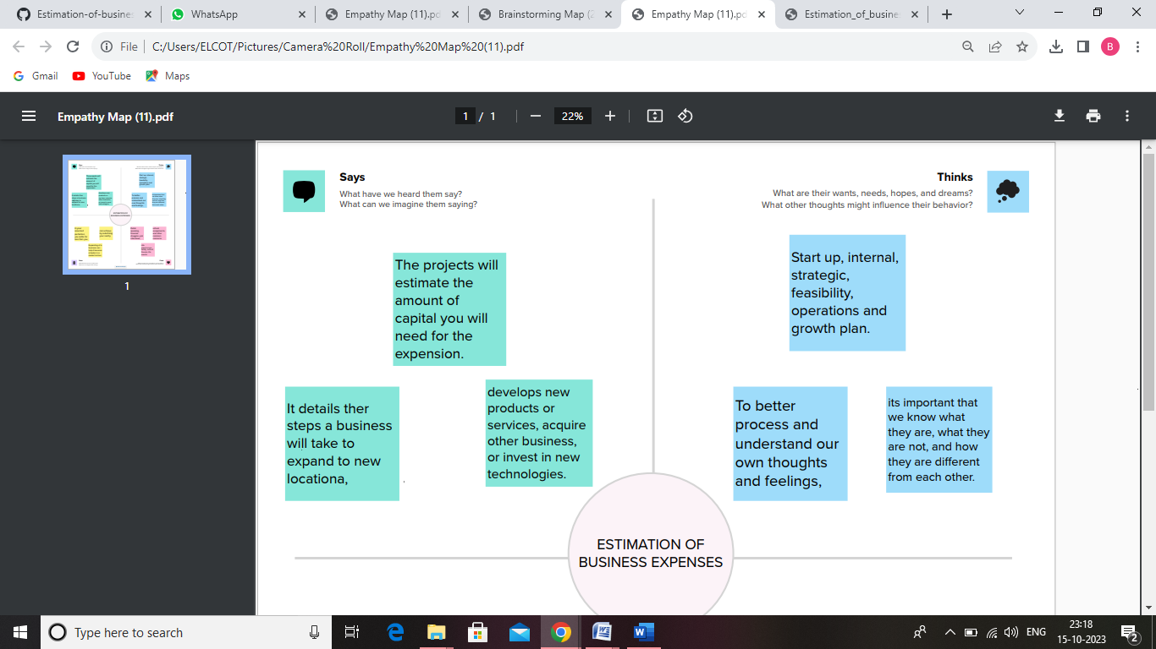



**2.2 Ideation & Brainstorming Map**

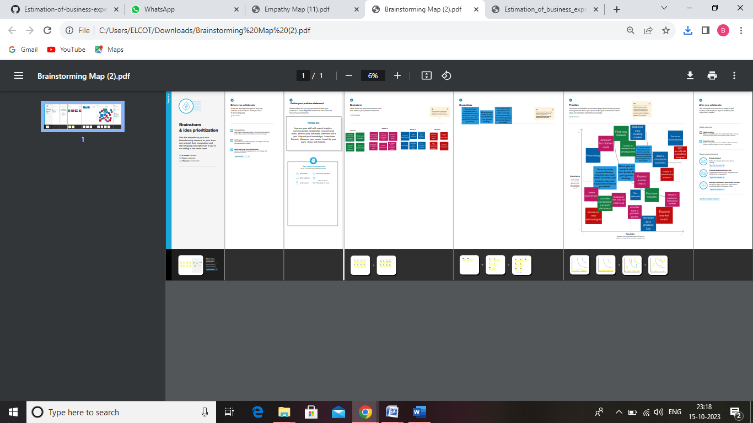

1. **RESULT**

**Dashboard 1**

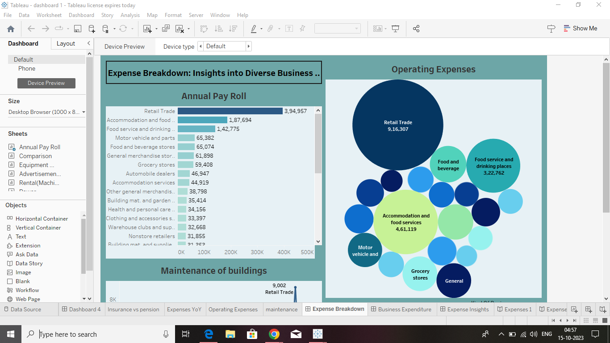

**Dashboard 2**

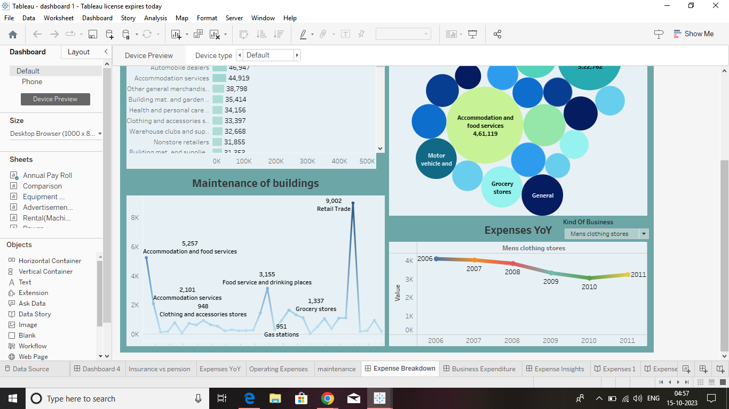

**Dashboard 3**

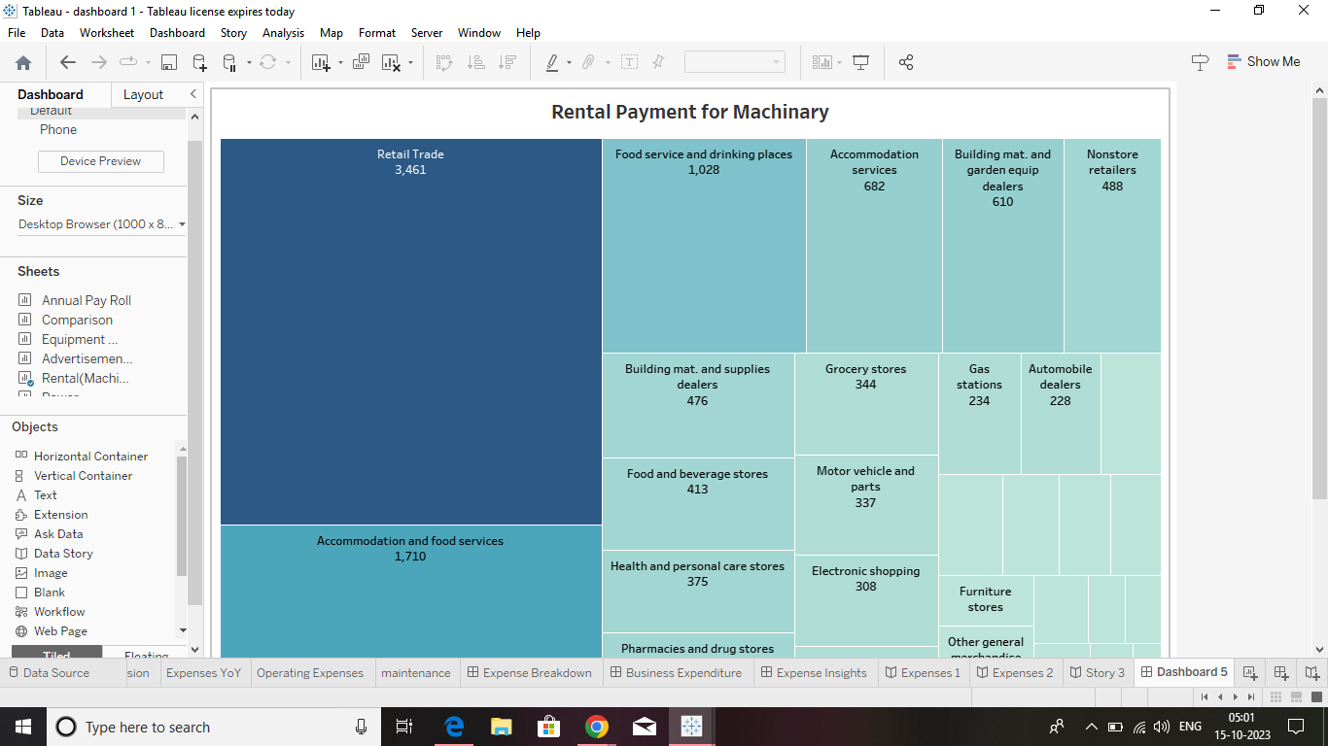

**Story 1**

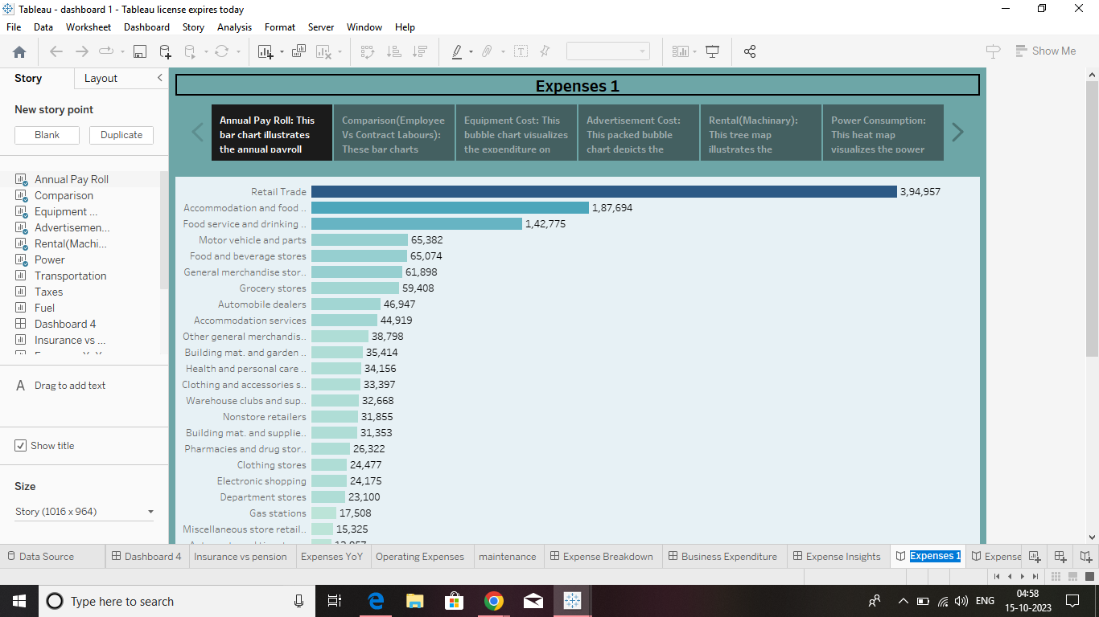

**Story 2**

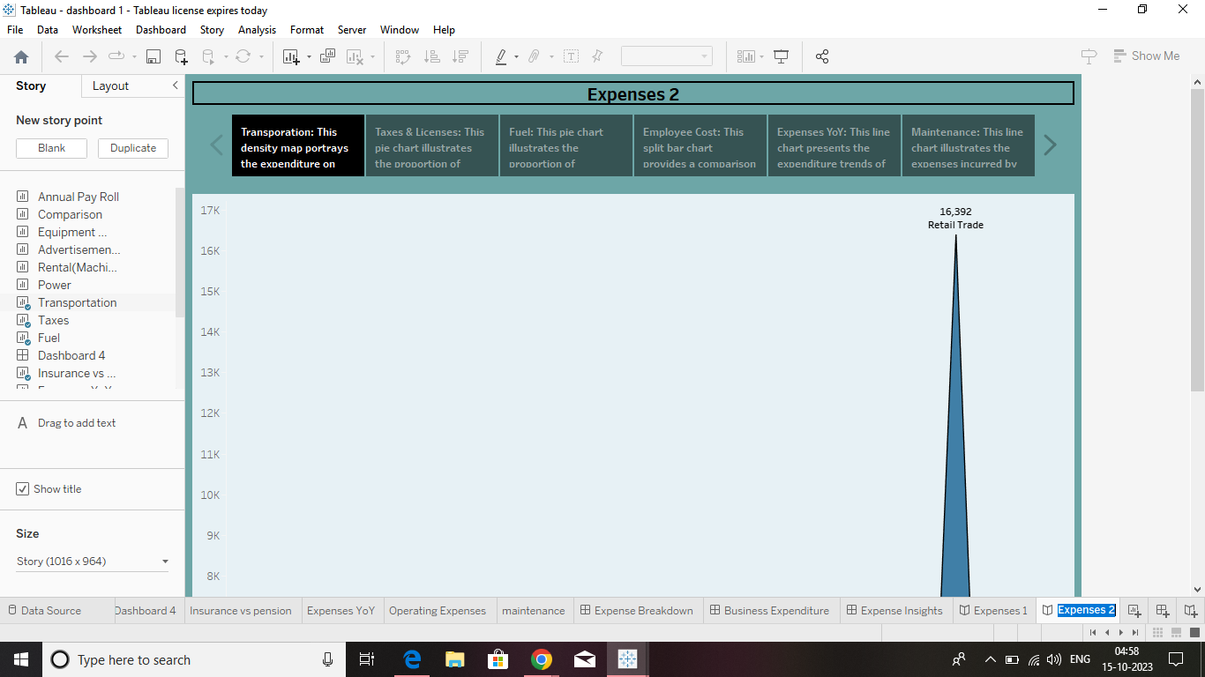

1. **ADVANTAGES & DISADVANTAGES**

**1 ] Measuring and Improving Efficiency. ...**

**Browse more Topics under Fundamentals Of Cost Accounting. ...**

**2] Identification of Unprofitable Activities. ...**

**3] Fixing Prices. ...**

**4] Price Reduction. ...**

**5] Control over Stock. ...**

**6] Evaluates the Reasons for Losses. ...**

**7] Aids Future Planning.**

1. **APPLICATIONS**

Social or Business Impact. Social Impact: The analysis of business expenses and financial management has a significant social impact. It contributes to economic stability by optimizing costs and fostering long-term sustainability. Effective expense management creates job opportunities and supports the workforce. It allows for better resource allocation, enabling businesses to invest in innovation and community engagement. Responsible expense management aligns with societal expectations and promotes social responsibility. Non-profit organizations benefit from expense analysis, enabling them to maximize their impact. Overall, analysing and managing expenses positively influences economic growth, employment, stakeholder well-being, and social responsibility. Business Impact: Analysing business expenses has a profound impact on various aspects of business operations. It helps optimize costs, improve profitability, and ensure financial stability. Expense analysis enables businesses to allocate resources effectively, make informed decisions, and create realistic budgets and forecasts. It enhances competitiveness, attracts investors, and mitigates financial risks. By understanding and managing expenses, companies can drive growth, maintain a strong financial position, and make strategic business decisions with confidence.

1. **CONCLUSION**

**First, we have to understand the given problem. Then, specify the business problem and collect the process of gathering and measuring information on variables of interest, evaluate outcomes and generate insights from the data. Then, download the data and understand the data, connect dataset with Tableau. After, connect dataset with Tableau, preparing the data for visualization involves cleaning the data to remove irrelevant or missing data. This process helps to make the data easily understandable and ready for creating visualizations to gain insights into the performance and efficiency. Then, the number of unique visualizations that can be created with a given dataset. Some common types of visualizations that can be used to analyses the performance and efficiency of banks include bar charts, line charts, pie charts etc. Once created views on different sheets in Tableau, then pull them into a dashboard. The number of scenes in a story for a data visualization analysis of the performance of banks will depend on the analysis and the specific insights that are trying to be conveyed. Then, publish dashboard, story, and reports to tableau public. Once upload was complete, a browser window will automatically open, displaying your published workbook on Tableau Public.**

1. **FUTURE SCOPE**

**My Future scope is nothing but, more features to add on tableau like download option for download the project. Then, it takes more times to open. So, make it is easy to operate.**